1. **Create an android application which shows the list of various food Items in a list view. Clicking on any food Item will show another activity with the food item details**

**Source Code :**

**MainActivity.java**

package com.example.quickbite;

import androidx.appcompat.app.AppCompatActivity;

import android.content.Intent;

import android.os.Bundle;

import android.view.View;

import android.widget.AdapterView;

import android.widget.ListView;

public class MainActivity extends AppCompatActivity {

ListView listView;

int[] imageList = {R.drawable.burgur, R.drawable.pizza, R.drawable.noddles, R.drawable.pasta, R.drawable.manchurian, R.drawable.sandwich, R.drawable.hotdog,R.drawable.birayani,R.drawable.friedrice,R.drawable.specialthali};

int[] descList = {R.string.burgur_description, R.string.pizza_description, R.string.noodles_description, R.string.pasta_description,R.string.sandwich_description,R.string.hot_dog_description, R.string.veg_biryani_description,R.string.fried_rice_description,R.string.special_thali_description};

String[] nameList = {"Burgur", "Pizza", "Noodles", "Pasta", "Manchurian", "Sandwich", "Hot Dog", "Veg Biryani", "Fried Rice", "Special Thali"};

String[] timeList = {"30 mins", "2 mins", "45 mins", "10mins", "15 Mins", "20 Mins", "10 Mins","15 Mins","10 Mins", "20 Mins"};

String[] price = {"200", "330","129", "99", "159","119", "150","250", "149", "399"};

@Override

protected void onCreate(Bundle savedInstanceState) {

super.onCreate(savedInstanceState);

setContentView(R.layout.activity_main);

listView = (ListView) findViewById(R.id.listView);

CustomeListView customeListView = new CustomeListView(getApplicationContext(),nameList,imageList,price);

listView.setAdapter(customeListView);

listView.setOnItemClickListener(new AdapterView.OnItemClickListener() {

@Override

public void onItemClick(AdapterView<?> parent, View view, int position, long id) {

Intent intent = new Intent(MainActivity.this, activity_details.class);

intent.putExtra("name",nameList[position]);

intent.putExtra("time", timeList[position]);

intent.putExtra("desc", descList[position]);

intent.putExtra("image", imageList[position]);

intent.putExtra("showprice",price[position]);

startActivity(intent);

}

});

}

}

**activity_main.xml**

<?xml version="1.0" encoding="utf-8"?>

<LinearLayout

xmlns:android="http://schemas.android.com/apk/res/android"

xmlns:app="http://schemas.android.com/apk/res-auto"

xmlns:tools="http://schemas.android.com/tools"

android:layout_width="match_parent"

android:layout_height="match_parent"

android:backgroundTint="@color/white"

android:orientation="vertical"

tools:context=".MainActivity">

<LinearLayout

android:layout_width="match_parent"

android:layout_height="wrap_content"

android:gravity="center">

<TextView

android:layout_width="wrap_content"

android:layout_height="wrap_content"

android:layout_gravity="center"

android:text="Quick Bite"

android:textStyle="bold"

android:textSize="30dp"

android:textColor="#23BEED"

android:padding="10dp"/>

</LinearLayout>

<ListView

android:id="@+id/listView"

android:layout_width="match_parent"

android:layout_height="match_parent"

android:layout_marginStart="12dp"

android:layout_marginTop="12dp"

android:layout_marginEnd="12dp"

android:divider="@android:color/transparent"

android:dividerHeight="10.0sp"

android:listSelector="#EDEDED"

android:scrollbars="vertical"

tools:listitem="@layout/activity_list_item" />

</LinearLayout>

**Output :**

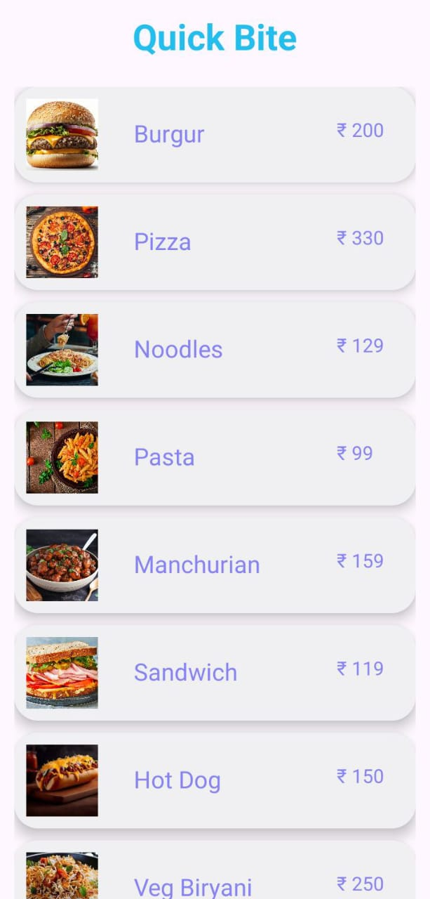

**list_item.java**

package com.example.quickbite;

import androidx.appcompat.app.AppCompatActivity;

import android.os.Bundle;

public class list_item extends AppCompatActivity {

@Override

protected void onCreate(Bundle savedInstanceState) {

super.onCreate(savedInstanceState);

setContentView(R.layout.activity_list_item);

}

}

**activity_list_item.xml**

<?xml version="1.0" encoding="utf-8"?>

<androidx.cardview.widget.CardView xmlns:android="http://schemas.android.com/apk/res/android"

android:layout_width="match_parent"

android:layout_height="wrap_content"

xmlns:app="http://schemas.android.com/apk/res-auto"

android:layout_marginStart="12dp"

android:layout_marginEnd="12dp"

android:layout_marginVertical="10dp"

android:layout_marginHorizontal="10dp"

app:cardCornerRadius="20dp"

app:cardElevation="8dp">

<RelativeLayout

android:layout_width="match_parent"

android:layout_height="wrap_content">

<com.google.android.material.imageview.ShapeableImageView

android:id="@+id/image"

android:layout_width="60dp"

android:layout_height="60dp"

android:src="@drawable/maggi"

android:scaleType="centerCrop"

android:layout_marginStart="10dp"

android:layout_marginBottom="10dp"

android:layout_marginTop="10dp" />

<TextView

android:layout_width="120dp"

android:layout_height="30dp"

android:id="@+id/name"

android:text="Name"

android:textColor="@color/lavender"

android:textSize="20sp"

android:layout_marginTop="25dp"

android:layout_marginStart="30dp"

android:layout_toEndOf="@id/image"/>

<TextView

android:layout_width="80dp"

android:layout_height="30dp"

android:id="@+id/price"

android:text="time"

android:textSize="16sp"

android:layout_toEndOf="@id/name"

android:layout_marginTop="25dp"

android:layout_marginStart="50dp"

android:textColor="@color/lavender"/>

</RelativeLayout>

</androidx.cardview.widget.CardView>

**CustomeListView.java**

package com.example.quickbite;

import android.content.Context;

import android.view.LayoutInflater;

import android.view.View;

import android.view.ViewGroup;

import android.widget.BaseAdapter;

import android.widget.ImageView;

import android.widget.TextView;

public class CustomeListView extends BaseAdapter {

Context context;

String names[];

int images[];

String price[];

LayoutInflater inflater;

public CustomeListView(Context ctx,String[] nm ,int[] img, String[] amount){

this.context = ctx;

this.images = img;

this.names = nm;

this.price = amount;

inflater = LayoutInflater.from(ctx);

}

@Override

public int getCount() {

return names.length;

}

@Override

public Object getItem(int position) {

return null;

}

@Override

public long getItemId(int position) {

return 0;

}

@Override

public View getView(int position, View convertView, ViewGroup parent) {

convertView = inflater.inflate(R.layout.activity_list_item,null);

TextView txtview = (TextView) convertView.findViewById(R.id.name);

ImageView img = (ImageView) convertView.findViewById(R.id.image);

TextView pricetxt = (TextView) convertView.findViewById(R.id.price);

txtview.setText(names[position]);

pricetxt.setText("₹ "+price[position]);

img.setImageResource(images[position]);

return convertView;

}

}

**Activity_details**

package com.example.quickbite;

import androidx.appcompat.app.AppCompatActivity;

import android.content.Intent;

import android.os.Bundle;

import android.view.View;

import android.widget.Button;

import android.widget.ImageView;

import android.widget.TextView;

import android.widget.Toast;

public class activity_details extends AppCompatActivity {

Button button ;

ImageView detailImage;

int quantity = 1,showprice;

TextView Desc,showtime,detailname,price,showquantity,increment,decrement;;

@Override

protected void onCreate(Bundle savedInstanceState) {

super.onCreate(savedInstanceState);

setContentView(R.layout.activity_details);

button = (Button) findViewById(R.id.btnplaceoder);

detailImage = (ImageView) findViewById(R.id.detailImage);

Desc = (TextView) findViewById(R.id.desc);

showtime = (TextView) findViewById(R.id.showtime);

price = (TextView) findViewById(R.id.price);

detailname = (TextView) findViewById(R.id.detailName);

showquantity = (TextView) findViewById(R.id.quantity);

increment = (TextView) findViewById(R.id.incrementButton);

decrement = (TextView) findViewById(R.id.decrementButton);

showquantity.setText(""+quantity);

Intent intent = this.getIntent();

if (intent != null) {

String name = intent.getStringExtra("name");

String time = intent.getStringExtra("time");

int desc = intent.getIntExtra("desc", R.string.manchurian_description);

int image = intent.getIntExtra("image", R.drawable.manchurian);

showprice = intent.getIntExtra("showprice",100);

detailname.setText(name);

showtime.setText("⌛" +time);

Desc.setText(desc);

price.setText("₹ "+showprice*quantity);

detailImage.setImageResource(image);

}

increment.setOnClickListener(new View.OnClickListener() {

@Override

public void onClick(View v) {

if(quantity < 20){

quantity++;

showquantity.setText(""+quantity);

price.setText("₹ "+showprice*quantity);

}else {

Toast.makeText(activity_details.this, "!! Max 20 item you can select at a time !!", Toast.LENGTH_SHORT).show();

}

}

});

decrement.setOnClickListener(new View.OnClickListener() {

@Override

public void onClick(View v) {

if(quantity > 1){

quantity--;

showquantity.setText(""+quantity);

price.setText("₹ "+showprice*quantity);

} else {

Toast.makeText(activity_details.this, "!! Quantity Can't to less than 1 !!", Toast.LENGTH_SHORT).show();

}

}

});

button.setOnClickListener(new View.OnClickListener() {

@Override

public void onClick(View v) {

Toast.makeText(activity_details.this, "Order Placed..!👍", Toast.LENGTH_SHORT).show();

Intent i=new Intent(getApplicationContext(),MainActivity.class);

startActivity(i);

}

});

}

}

**activity_details.xml**

<?xml version="1.0" encoding="utf-8"?>

<ScrollView xmlns:android="http://schemas.android.com/apk/res/android"

xmlns:app="http://schemas.android.com/apk/res-auto"

xmlns:tools="http://schemas.android.com/tools"

android:layout_width="match_parent"

android:layout_height="match_parent"

android:layout_margin="20dp"

android:backgroundTint="@color/white"

tools:context=".activity_details"

tools:ignore="ExtraText">

<LinearLayout

android:layout_width="match_parent"

android:layout_height="wrap_content"

android:orientation="vertical">

<androidx.cardview.widget.CardView

android:id="@+id/cardImage"

android:layout_width="380dp"

android:layout_height="220dp"

android:layout_gravity="center"

android:layout_margin="10dp"

app:cardCornerRadius="10dp"

app:cardElevation="8dp">

<ImageView

android:id="@+id/detailImage"

android:layout_width="match_parent"

android:layout_height="match_parent"

android:layout_gravity="center"

android:contentDescription="@string/todo"

android:scaleType="centerCrop"

android:src="@drawable/maggi" />

</androidx.cardview.widget.CardView>

<RelativeLayout

android:layout_width="match_parent"

android:layout_height="wrap_content">

<TextView

android:layout_width="100dp"

android:layout_height="wrap_content"

android:text="⭐4.5 Rating"

android:textColor="@color/black" />

<TextView

android:id="@+id/showtime"

android:layout_width="match_parent"

android:layout_height="wrap_content"

android:breakStrategy="balanced"

android:gravity="end"

android:text="⌛45min " />

</RelativeLayout>

<LinearLayout

android:layout_width="match_parent"

android:layout_height="wrap_content"

android:layout_marginTop="15dp"

android:orientation="horizontal">

<TextView

android:id="@+id/detailName"

android:layout_width="0dp"

android:layout_height="wrap_content"

android:layout_weight="1"

android:layout_marginStart="10dp"

android:text="@string/recipe_name"

android:textColor="#FAAF42"

android:textSize="24sp"

android:layout_gravity="center"

android:textStyle="bold" />

<LinearLayout

android:layout_width="wrap_content"

android:layout_height="wrap_content"

android:padding="5dp"

android:layout_marginEnd="5dp"

android:background="#FBEFEF"

android:orientation="horizontal">

<LinearLayout

android:layout_width="wrap_content"

android:layout_height="wrap_content">

<TextView

android:id="@+id/decrementButton"

android:layout_width="wrap_content"

android:layout_height="wrap_content"

android:textSize="30sp"

android:layout_gravity="center"

android:textStyle="bold"

android:text="-" />

<TextView

android:id="@+id/quantity"

android:layout_width="wrap_content"

android:layout_height="wrap_content"

android:layout_marginStart="10dp"

android:layout_marginEnd="10dp"

android:background="#ffffff"

android:layout_gravity="center"

android:text="0"

android:textSize="24sp"/>

<TextView

android:id="@+id/incrementButton"

android:layout_width="wrap_content"

android:layout_height="wrap_content"

android:textSize="30sp"

android:layout_gravity="center"

android:text="+"/>

</LinearLayout>

</LinearLayout>

</LinearLayout>

<TextView

android:layout_width="wrap_content"

android:layout_height="wrap_content"

android:layout_marginStart="10dp"

android:layout_marginTop="15dp"

android:text="Description"

android:textColor="@color/black"

android:textSize="20sp"

android:textStyle="bold" />

<TextView

android:id="@+id/desc"

android:layout_width="match_parent"

android:layout_height="wrap_content"

android:layout_marginStart="10dp"

android:layout_marginTop="10dp"

android:text="@string/descriptioninfo"

android:textColor="#605F5F"

android:textSize="18dp" />

<TextView

android:id="@+id/addno"

android:layout_width="wrap_content"

android:layout_height="wrap_content"

android:layout_marginStart="10dp"

android:layout_marginTop="25dp"

android:text="Add on"

android:textColor="@color/black"

android:textSize="20sp"

android:textStyle="bold" />

<androidx.cardview.widget.CardView

android:id="@+id/cardadd"

android:layout_width="match_parent"

android:layout_height="wrap_content"

app:cardCornerRadius="15dp"

app:cardUseCompatPadding="true">

<RadioGroup

android:layout_width="match_parent"

android:layout_height="wrap_content"

android:background="#FBFBF7"

android:padding="0dp">

<RadioButton

android:layout_width="match_parent"

android:layout_height="match_parent"

android:text=" Corn"

android:textSize="20dp" />

<RadioButton

android:layout_width="match_parent"

android:layout_height="wrap_content"

android:text=" Olive"

android:textSize="20dp" />

<RadioButton

android:layout_width="match_parent"

android:layout_height="wrap_content"

android:text=" Bell Pepper"

android:textSize="20dp" />

<RadioButton

android:layout_width="match_parent"

android:layout_height="wrap_content"

android:text=" Extra Cheese"

android:textSize="20dp" />

</RadioGroup>

</androidx.cardview.widget.CardView>

<RelativeLayout

android:layout_width="match_parent"

android:layout_height="52dp"

android:layout_marginTop="5dp"

android:layout_marginEnd="10dp"

android:gravity="center|bottom">

<TextView

android:id="@+id/price"

android:layout_width="wrap_content"

android:layout_height="wrap_content"

android:layout_marginStart="30dp"

android:layout_marginTop="5dp"

android:text="$19.00"

android:textSize="20dp" />

<TextView

android:layout_width="wrap_content"

android:layout_height="wrap_content"

android:layout_marginStart="28dp"

android:layout_marginTop="27dp"

android:text="included Taxes"

android:textSize="10dp"

tools:ignore="TextSizeCheck" />

<com.google.android.material.button.MaterialButton

android:id="@+id/btnplaceoder"

android:layout_width="match_parent"

android:layout_height="wrap_content"

android:layout_marginStart="40dp"

android:layout_toEndOf="@id/price"

android:backgroundTint="#FBA629"

android:gravity="center"

android:text="Place Order"

android:textSize="18dp"

app:cornerRadius="10dp" />

</RelativeLayout>

</LinearLayout>

</ScrollView>

Output :

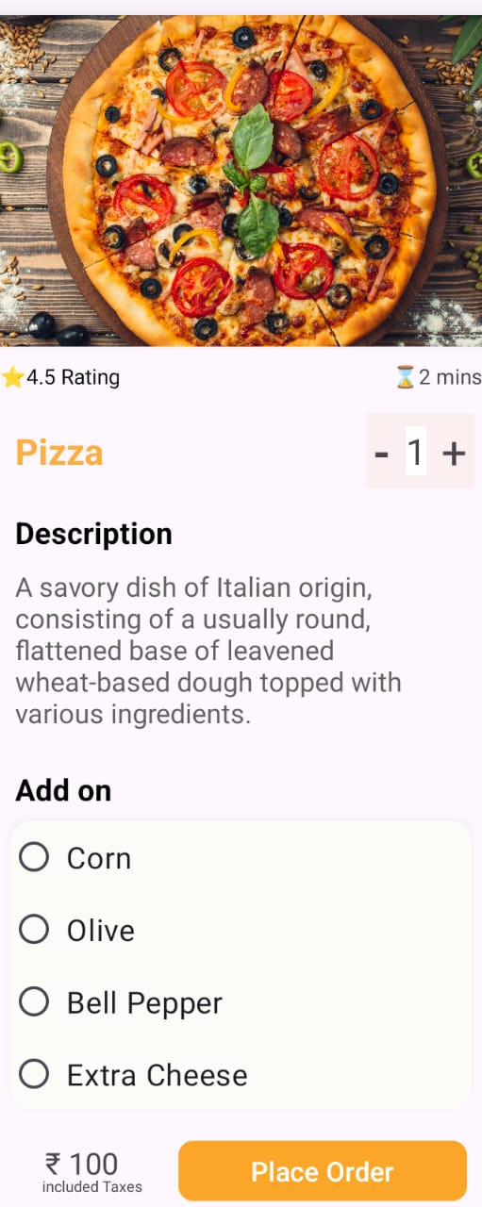

1. **Create a flutter application which shows the list of students in a list view. Clicking on any student will show another page with student’s details.**

**main.dart**

import 'package:flutter/material.dart';

import 'package:student_data/student_details.dart';

import 'model/student.dart';

void main() {

runApp(const MyApp());

}

class MyApp extends StatelessWidget {

const MyApp({Key? key}) : super(key: key);

@override

Widget build(BuildContext context) {

return MaterialApp(

title: 'Student Data',

theme: ThemeData(

primarySwatch: Colors.blue,

),

debugShowCheckedModeBanner: false,

home: const StudentList(),

);

}

}

class StudentList extends StatelessWidget {

const StudentList({Key? key}) : super(key: key);

@override

Widget build(BuildContext context) {

final student = students;

return Scaffold(

appBar: AppBar(

title: const Text(

"SDJ International Collage",

style: TextStyle(

fontWeight: FontWeight.bold,

color: Colors.white, // Set text color to white

),

),

backgroundColor: const Color(0xFF52B8F7),

elevation: 0,

centerTitle: true,

),

backgroundColor: const Color(0xFF52B8F7),

body: SingleChildScrollView(

child: Column(

crossAxisAlignment: CrossAxisAlignment.start,

children: [

students.isEmpty

? const Center(

child: Text(

'No students available',

style: TextStyle(fontSize: 18),

),

)

: ListView.builder(

physics: const NeverScrollableScrollPhysics(),

shrinkWrap: true,

itemCount: student.length,

itemBuilder: (context, index) {

final student = students[index];

return Padding(

padding: const EdgeInsets.all(10),

child: Card(

color: Colors.white,

elevation: 5,

child: ListTile(

onTap: () {

Navigator.push(

context,

MaterialPageRoute(

builder: (context) =>

StudentDetails(student: students[index]),

),

);

},

leading: CircleAvatar(

backgroundImage: NetworkImage(student.imageUrl),

),

title: Text(

student.name,

style: const TextStyle(

fontSize: 20,

color: Colors.black,

),

),

subtitle: Text(

"Class : " + student.Class,

style: const TextStyle(

fontSize: 15,

),

),

),

),

);

},

),

],

),

),

);

}

}

**student.dart**

class Student {

final String name;

final String imageUrl;

final String Class;

final int rollNo;

Student({

required this.name,

required this.imageUrl,

required this.Class,

required this.rollNo,

});

}

List<Student> students = [

Student(

name: "Vinayak Purohit",

imageUrl: "https://cdn.pixabay.com/photo/2020/07/01/12/58/icon-5359553_640.png",

Class: "SYBCA",

rollNo: 872,

),

Student(

name: "Shailesh Prajapti",

imageUrl: "https://encrypted-tbn0.gstatic.com/images?q=tbn:ANd9GcRASaDRmInbjo1pwypLMkP3Z3LC1UeAymCAEh0ZUlM-Ww&s",

Class: "SYBCA",

rollNo: 871,

),

Student(

name: "Vishal Purohit",

imageUrl: "https://encrypted-tbn0.gstatic.com/images?q=tbn:ANd9GcQK_BCyNz54BP19xEJsd01kUxzd-GdtIMn_Ew",

Class: "SYBCOM",

rollNo: 798,

),

Student(

name: "Ketan Lad",

imageUrl: "https://encrypted-tbn0.gstatic.com/images?q=tbn:ANd9GcRkiIFjCOZ-mMeqxd2ryrneiHedE8G9S0AboA&usqp=CAU",

Class: "SYBCA",

rollNo: 838,

),

Student(

name: "Divyesh Rawal",

imageUrl: "https://encrypted-tbn0.gstatic.com/images?q=tbn:ANd9GcRDWNeajmNh6MxbMbl21K71y8PuOtx9klR4FXYKx_reslyhcfce-SwSyJRmJM_BMCDfVI8",

Class: "SYBCOM",

rollNo: 235,

),

Student(

name: "Mahesh Prajapati",

imageUrl: "https://encrypted-tbn0.gstatic.com/images?q=tbn:ANd9GcRDWNeajmNh6MxbMbl21K71y8PuOtx9klR4FXYKx_reslyhcfce-SwSyJRmJM_BMCDfVI8",

Class: "TYBCA",

rollNo: 897,

),

];

**Output:**



**student.dart**

import 'package:flutter/material.dart';

import 'package:student_data/model/student.dart';

class StudentDetails extends StatelessWidget {

final Student student;

const StudentDetails({

Key? key,

required this.student,

}) : super(key: key);

@override

Widget build(BuildContext context) {

return Scaffold(

backgroundColor: Colors.white70,

appBar: AppBar(

title: const Text("Student Details"),

elevation: 0,

backgroundColor: Colors.blue,

),

body: Padding(

padding: const EdgeInsets.all(16),

child: Column(

crossAxisAlignment: CrossAxisAlignment.center,

children: [

const Text(

"SDJ International Collage",

style: TextStyle(

fontSize: 24,

fontWeight: FontWeight.bold,

),

),

const SizedBox(height: 16),

Center(

child: Column(

children: [

CircleAvatar(

backgroundImage: NetworkImage(student.imageUrl),

radius: 50,

),

const SizedBox(height: 45),

Text(

"NAME:- ${student.name}",

style: const TextStyle(fontSize: 20),

),

const SizedBox(height: 16),

Text(

"CLASS:- ${student.Class}",

style: const TextStyle(fontSize: 20),

),

const SizedBox(height: 16),

Text(

"ROLL No:- ${student.rollNo}",

style: const TextStyle(fontSize: 20),

),

],

),

),

],

),

),

);

}

}

**Output :**

